

# 

### Semester One Examination, 2017

### Question/Answer booklet

# MATHEMATICS

If required by your examination administrator, please place your student identification label in this box

**METHODS**

**UNIT 3**

## Section Two:

## Calculator-assumed

|  |  |  |  |  |  |  |  |  |  |  |
| --- | --- | --- | --- | --- | --- | --- | --- | --- | --- | --- |
| Student Number: In figures |  |  |  |  |  |  |  |  |  |  |

In words

Your name

TEACHER _______________________________________

## Time allowed for this section

Reading time before commencing work: ten minutes

Working time: one hundred minutes

## Materials required/recommended for this section

***To be provided by the supervisor***

This Question/Answer booklet

Formula sheet (retained from Section One)

***To be provided by the candidate***

Standard items: pens (blue/black preferred), pencils (including coloured), sharpener, correction fluid/tape, eraser, ruler, highlighters

Special items: drawing instruments, templates, notes on two unfolded sheets of A4 paper, and up to three calculators approved for use in this examination

## Important note to candidates

No other items may be taken into the examination room. It is **your** responsibility to ensure that you do not have any unauthorised material. If you have any unauthorised material with you, hand it to the supervisor **before** reading any further.

## Structure of this paper

|  |  |  |  |  |  |
| --- | --- | --- | --- | --- | --- |
| Section | Number of questions available | Number of questions to be answered | Working  time (minutes) | Marks available | Percentage of examination |
| Section One:  Calculator-free | 8 | 8 | 50 | 52 | 35 |
| Section Two:  Calculator-assumed | 11 | 11 | 100 | 98 | 65 |
|  | | |  | **Total** | 100 |

## Instructions to candidates

1. The rules for the conduct of examinations are detailed in the school handbook. Sitting this examination implies that you agree to abide by these rules.

2. Write your answers in this Question/Answer booklet.

3. You must be careful to confine your response to the specific question asked and to follow any instructions that are specified to a particular question.

4. Additional working space pages at the end of this Question/Answer booklet are for planning or continuing an answer. If you use these pages, indicate at the original answer, the page number it is planned/continued on and write the question number being planned/continued on the additional working space page.

5. Show all your working clearly. Your working should be in sufficient detail to allow your answers to be checked readily and for marks to be awarded for reasoning. Incorrect answers given without supporting reasoning cannot be allocated any marks. For any question or part question worth more than two marks, valid working or justification is required to receive full marks. If you repeat any question, ensure that you cancel the answer you do not wish to have marked.

6. It is recommended that you do not use pencil, except in diagrams.

7. The Formula sheet is not to be handed in with your Question/Answer booklet.

Section Two: Calculator-assumed 65% (98 Marks)

This section has**eleven (****11)** questions. Answer **all** questions. Write your answers in the spaces provided.

Working time: 100 minutes.

**____________________________________________________________________________________**

**Question 9 (7 marks)**

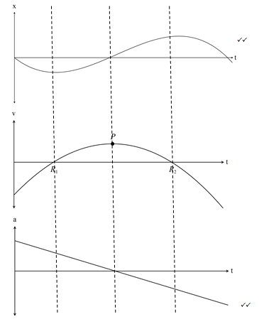

(b) The roots of occur at the same t value as the turning points on .

At  , i.e. the turning point in 

is a minimum.

At  , i.e. the turning point in 

✓

is a maximum.

The turning point of , P, has a zero gradient so its derivative, 

has a zero value at .

The gradient of is positive for and is negative for , so the

✓

linear function is a decreasing value with an x intercept at .

Question 10 (7 marks)

The voltage between the plates of a discharging capacitor can be modelled by the function $V\left(t\right)=14e^{kt}$, where $V$ is the voltage in volts, $t$ is the time in seconds and $k$ is a constant.

It was observed that after three minutes the voltage between the plates had decreased to 0.6 volts.

(a) State the initial voltage between the plates. (1 mark)

|  |
| --- |
| **Solution** |
| $$V_{0}=14 \text{volts}$$ |
| **Specific behaviours** |
| ✓ states value (units not required) |

(b) Determine the value of $k$. (2 marks)

|  |
| --- |
| **Solution** |
| $$0.6=14e^{180k}$$ $$k=-0.0175$$ |
| **Specific behaviours** |
| ✓ writes equation  ✓ solves, rounding to 3sf |

(c) How long did it take for the initial voltage to halve? (2 marks)

|  |
| --- |
| **Solution** |
| $$0.5=e^{-0.0175t}$$ $$t=39.6 \text{s}$$ |
| **Specific behaviours** |
| ✓ writes equation  ✓ solves, rounding to 3sf |

(d) At what rate was the voltage decreasing at the instant it reached 8 volts? (2 marks)

|  |
| --- |
| **Solution** |
| $$V^{'}\left(t\right)=kV$$ $$=-0.0175×8=-0.14$$ $$\text{Decreasing at 0.14 volts/s}$$ |
| **Specific behaviours** |
| ✓ uses rate of change  ✓ states decrease, dropping negative sign |

Question 11 (7 marks)

(a) Four random variables $W$, $X$, $Y$ and $Z$ are defined below. State, with reasons, whether the distribution of the random variable is Bernoulli, binomial, uniform or none of these.

(4 marks)

*The dice referred to is a cube with faces numbered with the integers 1, 2, 3, 4, 5 and 6.*

(i) $W$ is the number of throws of a dice until a six is scored.

|  |
| --- |
| **Solution** |
| Neither - distribution is geometric |
| **Specific behaviours** |
| ✓ answer with reason |

(ii) $X$ is the score when a dice is thrown.

|  |
| --- |
| **Solution** |
| Uniform - all outcomes are equally likely |
| **Specific behaviours** |
| ✓ answer with reason |

(iii) $Y$ is the number of odd numbers showing when a dice is thrown.

|  |
| --- |
| **Solution** |
| Bernoulli - two complementary outcomes |
| **Specific behaviours** |
| ✓ answer with reason |

(iv) $Z$ is the total of the scores when two dice are thrown.

|  |
| --- |
| **Solution** |
| Neither - distribution is triangular |
| **Specific behaviours** |
| ✓ answer with reason |

(b) Pegs produced by a manufacturer are known to be defective with probability $p$, independently of each other. The pegs are sold in bags of $n$ for $4.95. The random variable $X$ is the number of faulty pegs in a bag.

If $E\left(X\right)=1.8$ and $Var\left(X\right)=1.728$, determine $n$ and $p$. (3 marks)

|  |
| --- |
| **Solution** |
| $$np=1.8, np\left(1-p\right)=1.728$$ $$∴1-p=\frac{1.728}{1.8}=0.96$$ $$p=0.04$$ $$n=\frac{1.8}{0.04}=45$$ |
| **Specific behaviours** |
| ✓ writes equations for mean and variance  ✓ solves for  ✓ solves for $n$ |

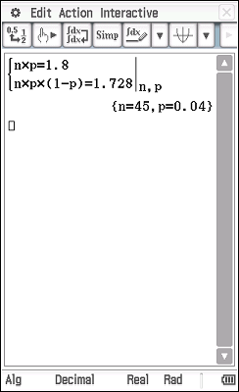

Question 12 (9 marks)

75% of the avocados produced by a farm are known to be first grade, the rest being second grade. Trays of 24 avocados are filled at random in a packing shed and sent to market.

Let the random variable $X$ be the number of first grade avocados in a single tray.

(a) Explain why $X$ is a discrete random variable, and identify its probability distribution.

(2 marks)

|  |
| --- |
| **Solution** |
| $X$ is a DRV as it can only take integer values from 0 to 24. $X$ follows a binomial distribution: $X\sim B(24, 0.75)$ |
| **Specific behaviours** |
| ✓ explanation using discrete values  ✓ identifies binomial, with parameters |

(b) Calculate the mean and standard deviation of $X$. (2 marks)

|  |
| --- |
| **Solution** |
| $$\overline{X}=24×0.75=18$$ $$σ_{x}=\sqrt{18×0.25}=\frac{3\sqrt{2}}{2}≈2.12$$ |
| **Specific behaviours** |
| ✓ mean, ✓ standard deviation |

(c) Determine the probability that a randomly chosen tray contains

(i) 18 first grade avocados. (1 mark)

|  |
| --- |
| **Solution** |
| $$P\left(X=18\right)=0.1853$$ |
| **Specific behaviours** |
| ✓ probability |

(ii) more than 15 but less than 20 first grade avocados. (2 marks)

|  |
| --- |
| **Solution** |
| $$P\left(16≤X≤19\right)=0.6320$$ |
| **Specific behaviours** |
| ✓ uses correct bounds  ✓ probability |

(d) In a random sample of 1000 trays, how many trays are likely to have fewer first grade than second grade avocados. (2 marks)

|  |
| --- |
| **Solution** |
| $$P\left(X≤11\right)=0.0021$$ $$0.0021×1000≈2 \text{trays}$$ |
| **Specific behaviours** |
| ✓ identifies upper bound and calculates probability  ✓ calculates whole number of trays |

Question 113 (8 marks)

The speed, in metres per second, of a car approaching a stop sign is shown in the graph below and can be modelled by the equation $v\left(t\right)=6\left(1+\cos\left(0.25t\right)+\sin^{2}\left(0.25t\right)\right)$, where $t$ represents the time in seconds.

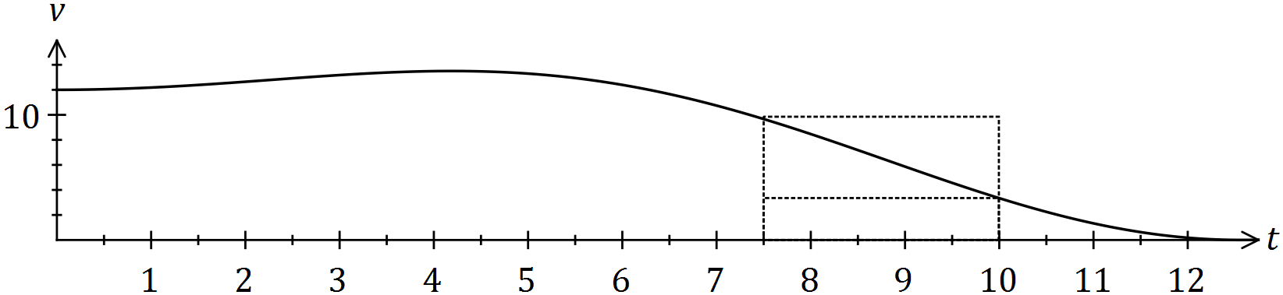

The area under the curve for any time interval represents the distance travelled by the car.

(a) Complete the table below, rounding to two decimal places. (2 marks)

|  |  |  |  |  |  |
| --- | --- | --- | --- | --- | --- |
| $$t$$ | $$0$$ | $$2.5$$ | $$5$$ | $$7.5$$ | $$10$$ |
| $$v(t)$$ | 12.00 | 12.92 | 13.30 | 9.66 |  |

|  |
| --- |
| **Solution** |
| See table |
| **Specific behaviours** |
| ✓ values, ✓ rounding |

(b) Complete the following table and hence estimate the distance travelled by the car during the first ten seconds by calculating the mean of the sums of the inscribed areas and the circumscribed areas, using four rectangles of width 2.5 seconds.

*(The rectangles for the 7.5 to 10 second interval are shown on the graph.)* (5 marks)

|  |  |  |  |  |
| --- | --- | --- | --- | --- |
| Interval | $$0-2.5$$ | $$2.5-5$$ | $$5-7.5$$ | $$7.5-10$$ |
| Inscribed area | 30.0 | 32.3 | 24.15 | $$8.35$$ |
| Circumscribed area | 32.3 | 33.25 | 33.25 |  |

|  |
| --- |
| **Solution** |
| See table (*may have slightly different values if using exact values of $v(t)$ rather than those from (a)) $$\sum{\text{Inscribed}}=94.8, \sum{\text{Circumscribed}}=122.95$$ $$\text{Estimate}=\frac{94.8+122.95}{2}≈108.9 \text{m}$$* |
| **Specific behaviours** |
| ✓ values 1st col, ✓ values 2nd col, ✓ values 3rd col  ✓ sums  ✓ estimate that rounds to 109 |

(c) Suggest one change to the above procedure to improve the accuracy of the estimate.

(1 mark)

|  |
| --- |
| **Solution** |
| Use a larger number of thinner rectangles. |
| **Specific behaviours** |
| ✓ valid suggestion |

Question 14 (10 marks)

A slot machine is programmed to operate at random, making various payouts after patrons pay $2 and press a start button. The random variable $X$ is the amount of the payout, in dollars, in one play of the machine. Each payout can be assumed to be independent of other payouts.

The probability, $P$, that the machine makes a certain payout, $x$, is shown in the table below.

|  |  |  |  |  |  |  |  |  |
| --- | --- | --- | --- | --- | --- | --- | --- | --- |
| Payout ($) $x$ | 0 | 1 | 2 | 5 | 10 | 20 | 50 | 100 |
| Probability $P(X=x)$ | 0.25 | 0.45 | 0.2125 | 0.0625 | 0.0125 | 0.005 | 0.005 | 0.0025 |

(a) Determine the probability that

(i) in one play of the machine, a payout of more than $1 is made. (1 mark)

|  |
| --- |
| **Solution** |
| $$P\left(X>1\right)=1-\left(0.25+0.45\right)=0.3$$ |
| **Specific behaviours** |
| ✓ states probability |

(ii) in ten plays of the machine, it makes a payout of $5 no more than once. (2 marks)

|  |
| --- |
| **Solution** |
| $$Y\sim B\left(10, 0.0625\right)$$ $$P\left(Y≤1\right)=0.8741$$ |
| **Specific behaviours** |
| ✓ indicates binomial distribution  ✓ calculates probability |

(iii) in five plays of the machine, the second payout of $1 occurs on the fifth play.

(3 marks)

|  |
| --- |
| **Solution** |
| First payout in one of four plays: $$W\sim B\left(4, 0.45\right)$$ $$P\left(W=1\right)=0.2995$$ Second payout: $$P=0.2995×0.45=0.1348$$ |
| **Specific behaviours** |
| ✓ uses first and second event  ✓ calculates $P$ for first event  ✓ calculates $P$ for both events |

(b) Calculate the mean and standard deviation of $X$. (2 marks)

|  |
| --- |
| **Solution** |
| $$\overline{X}=1.9125, σ_{X}=6.321$$ |
| **Specific behaviours** |
| ✓ mean  ✓ sd |

(c) In the long run, what percentage of the player's money is returned to them? (2 marks)

|  |
| --- |
| **Solution** |
| $$\frac{1.9125}{2}×100=95.625\%$$ |
| **Specific behaviours** |
| ✓ uses mean and payment  ✓ calculates percentage |

Question 15 (6 marks)

Let the random variable $X$ be the number of vowels in a random selection of four letters from those in the word LOGARITHM, with no letter to be chosen more than once.

(a) Complete the probability distribution of $X$ below. (1 mark)

|  |  |  |  |  |
| --- | --- | --- | --- | --- |
|  |  |  |  |  |
|  |  |  |  |  |

|  |
| --- |
| **Solution** |
| $$1-\left(\frac{5}{42}+\frac{10}{21}+\frac{1}{21}\right)=\frac{5}{14}$$ |
| **Specific behaviours** |
| ✓ uses sum of probabilities |

(b) Show how the probability for $P(X=1)$ was calculated. (2 marks)

|  |
| --- |
| **Solution** |
| $$P\left(X=1\right)=\frac{\left(\begin{matrix}3 \\ 1\end{matrix}\right)×\left(\begin{matrix}6 \\ 3\end{matrix}\right)}{\left(\begin{matrix}9 \\ 4\end{matrix}\right)}=\frac{3×20}{126}=\frac{10}{21}$$ |
| **Specific behaviours** |
| ✓ uses combinations for numerator  ✓ uses combinations for denominator and simplifies |

(c) Determine $P(X≥1|X≤2)$. (2 marks)

|  |
| --- |
| **Solution** |
| $$P=\frac{\frac{10}{21}+\frac{5}{14}}{\frac{20}{21}}=\frac{5/6}{20/21}=\frac{7}{8}$$ |
| **Specific behaviours** |
| ✓ obtains numerator  ✓ obtains denominator and simplifies |

Let event $A$ occur when no vowels are chosen in random selection of four letters from those in the word LOGARITHM.

(d) State $P(\overline{A})$. (1 mark)

|  |
| --- |
| **Solution** |
| $$P\left(\overline{A}\right)=1-\frac{5}{42}=\frac{37}{42}$$ |
| **Specific behaviours** |
| ✓ calculates probability |

**Question 16 (6 marks)**

The base radius of a conical pile of sand is twice its height. If the volume of the sand is initially 60 $m^{3}$ and then another 1 of sand is added, use the increments formula to estimate the increase in the height of pile.

Quote your result in millimetres and you should assume that that radius of the cone remains twice its height.

|  |  |
| --- | --- |
| Solution    When  and    Since  So the height increases by about 13 millimetres | |
| Marking key/mathematical behaviours | Marks |
| * expresses the volume as a function of height only * evaluates * differentiates correctly and evaluates $\frac{dV}{dh}$* uses increments formula correctly * gives correct answer | 1  1  1+1  1  1 |

**Question 16 (11 marks)**

(11 marks)

The profit for the first few months of a company vary according to the function , where t represents months.

Hint: Use radians.

(a) FInd the first and second derivatives of the profit function and explain exactly

how these derivatives could help you graph the function. (6)

(a) 



✓ ✓

✓ ✓

Find where = 0 to find the turning points then use  to identify the types of turning points.

If < 0 then maximum turning point. If > 0 then minimum turning point.

If = 0 then you have the t value so you can find the points of inflection. ✓✓

(b) Sketch the profit equation on the set of axes. (3)

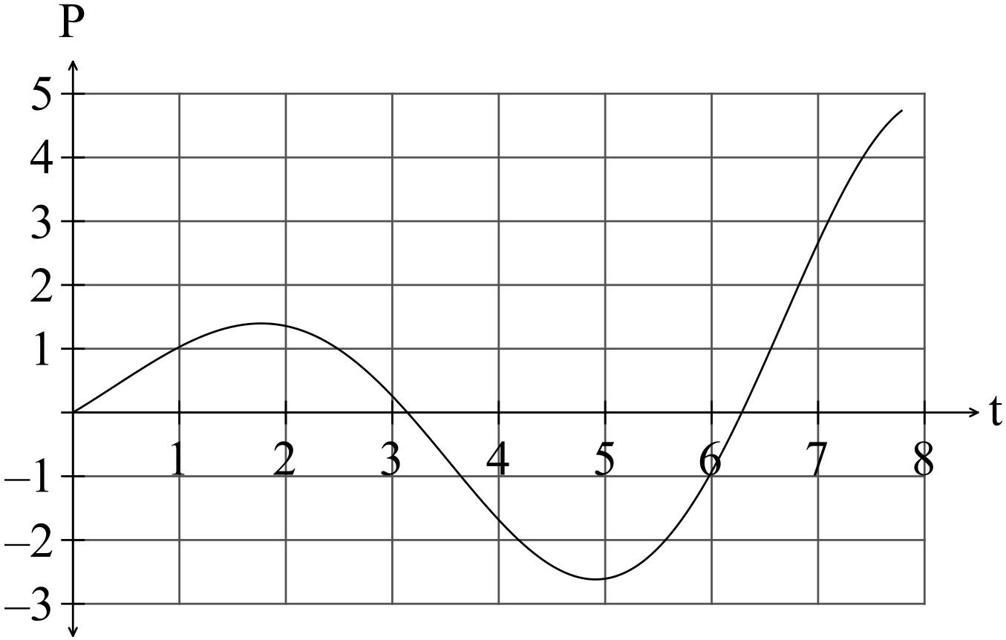 ✓✓✓ -1/error

After the first two months when the profit had been increasing, the owner employed more staff and it took a little while for sales to start to increase again.

(c) Determine when the profit started to increase again. (1

The profit started to increase again at  ✓

(d) Determine when the break even point was reached i.e. when profit again became positive. (1)

The break even point was reached at  ✓

**Question 17 (6 marks)**

The base radius of a conical pile of sand is twice its height. If the volume of the sand is initially 60 $m^{3}$ and then another 1 of sand is added, use the increments formula to estimate the increase in the height of pile.

Quote your result in millimetres and you should assume that that radius of the cone remains twice its height.

|  |  |
| --- | --- |
| Solution    When  and    Since  So the height increases by about 13 millimetres | |
| Marking key/mathematical behaviours | Marks |
| * expresses the volume as a function of height only * evaluates * differentiates correctly and evaluates $\frac{dV}{dh}$* uses increments formula correctly * gives correct answer | 1  1  1+1  1  1 |

**Question 18**

(5 marks)

(a)

|  |  |  |  |  |  |  |
| --- | --- | --- | --- | --- | --- | --- |
| *x* | 0 | 1 | 2 | 3 | 4 | 5 |
| *P*(*X = x*) | 0.17 | 0.36 | 0.31 | 0.13 | 0.03 | 0.00 |

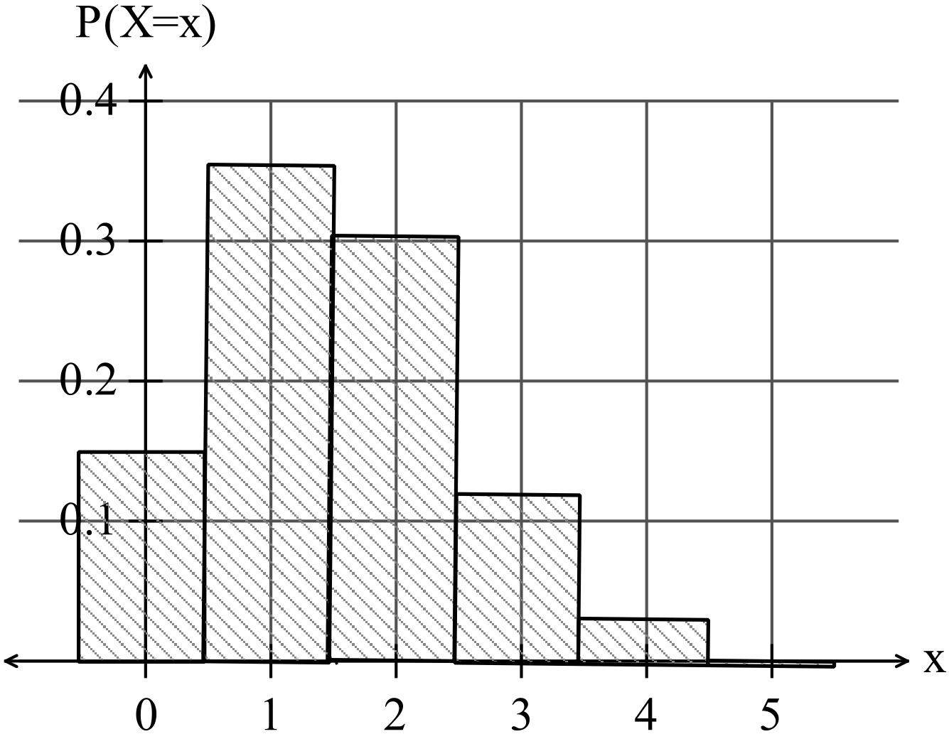

✓✓✓✓ -1/error

(b) p = 0.7

**Question 19 (11 marks)**

The gradient function of $f$ is given by $f^{'}(x)=12x^{3}-24x^{2}$.

(a) Show that the graph of $y=f(x)$ has two stationary points. (2 marks)

|  |
| --- |
| **Solution** |
| $$\text{Require} f^{'}\left(x\right)=0 \\ 12x^{2}\left(x-2\right)=0 \\ x=0, x=2$$ $$\text{Hence two stationary points}$$ |
| **Specific behaviours** |
| ✓ equates derivative to zero and factorises  ✓ shows two solutions and concludes two stationary points |

(b) Determine the interval(s) for which the graph of the function is concave upward. (3 marks)

|  |
| --- |
| **Solution** |
| $$f^{''}\left(x\right)=36x^{2}-48x$$ $$f^{''}\left(x\right)>0⇒x<0,x>\frac{4}{3}$$ |
| **Specific behaviours** |
| ✓ shows condition for concave upwards  ✓ uses second derivative  ✓ states intervals |

(c) Given that the graph of $y=f(x)$ passes through $(1, 0)$, determine $f(x)$. (2 marks)

|  |
| --- |
| **Solution** |
| $$f\left(x\right)=\int{f^{'}\left(x\right)}dx=3x^{4}-8x^{3}+c$$ $$f\left(1\right)=0⇒c=5$$ $$f\left(x\right)=3x^{4}-8x^{3}+5$$ |
| **Specific behaviours** |
| ✓ integrates  ✓ determines constant |

(d) Sketch the graph of $y=f(x)$, indicating all key features. (4 marks)

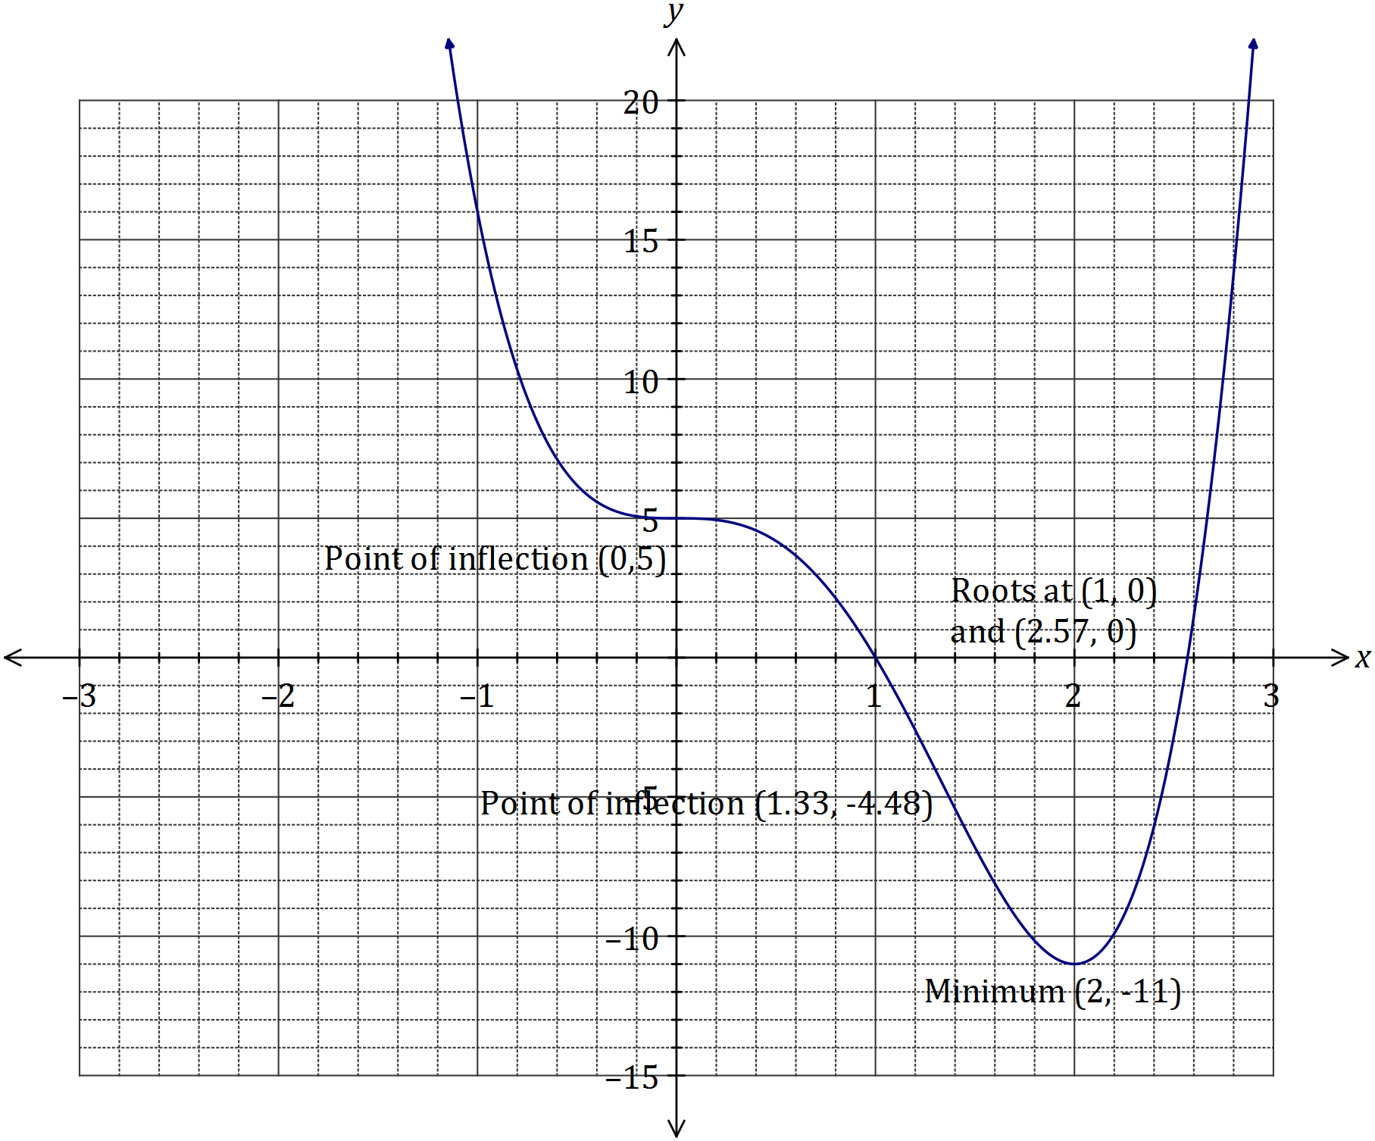

|  |
| --- |
| **Solution** |
| See graph |
| **Specific behaviours** |
| ✓ minimum  ✓ roots  ✓ points of inflection  ✓ smooth curve |

**Question 20 (9 marks)**

(a) The area of the region bounded by the curve  ,where *k* is a positive constant, the *x*-axis, and the line *x* = 9 is 27. Determine the value of *k*. (3 marks)

|  |  |
| --- | --- |
| Solution $$\int_{0}^{9}{kx^{\frac{1}{2}} dx = 27}$$ $$\int_{0}^{9}{kx^{\frac{1}{2}} dx = \frac{2}{3}} k\left.\sqrt{x^{3}} \right]{9 \atop 0}$$ = $18k$ $$18k=27$$ $k = \frac{3}{2}$ | |
| Marking key/mathematical behaviours | Marks |
| * correctly integrates * correctly substitutes limits * correctly solves | 1  1  1 |

(b) For the domain , the curves  and  intersect at

, and  where .

(i) Determine the values of a, b and c. (3 marks)

(ii) Write down an integral to calculate the total area bounded by the two curves for the domain . (2 marks)

(iii) Evaluate the integral established in part (ii). (1 mark)

intersect when

|  |  |
| --- | --- |
| Solution  (i) a = –2.658, b = 0, c = 0.978  (ii)  (iii) Area = 2.244 square units | |
| Marking key/mathematical behaviours | Marks |
| * states correct values of a, b and c for part (i) * states correct integral for part (ii) * correctly solves for the area in part (iii) | 3  2  1 |

**Question 21 (5 marks)**

(a) 

✓



✓

(b) 

✓

The annual rate of growth of the population is 1.8123%

(c) 

The annual rate of growth of the population is now 1.1776414% so the rate of growth of the population has slowed down considerably.

✓

(d) 

✓

